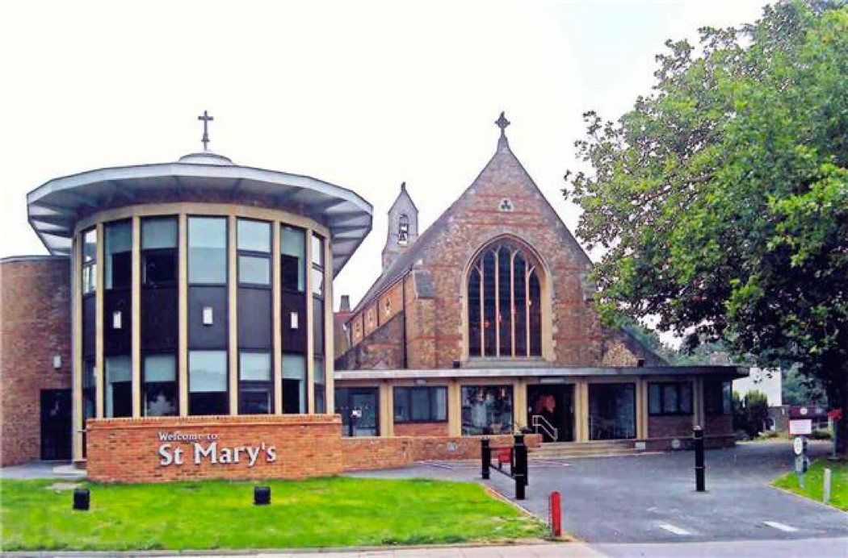

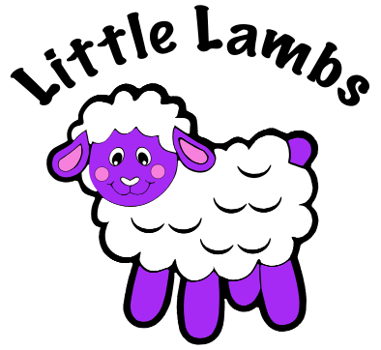
Little Lambs
St Mary’s Church, 201 High Road, Loughton,
Essex IG10 1BB
Tel: 07769 433023
E-mail: littlelambs@stmarysloughton.com
Registration Pack

Little Lambs
St Mary’s Church
201 High Road
Loughton
Essex IG10 1BB
Tel: 07769 433023
E-mail: littlelambs@stmarysloughton.com

Welcome to Little Lambs @ St Mary’s
Dear Parents/Carers,
Little Lambs is a private nursery which opened in September 2008 within a Christian setting located in St Mary’s Church, Parish Rooms, in the centre of Loughton’s High Road. We run two sessions during the day and are open during term time between 9:15 am and 2:45 pm, Monday to Friday. We provide care for children from 2 to 5 years of age.
We have all the modern features required to provide children with a safe, secure and warm environment; in which they will be happy to play, learn and develop. Our very committed staff ensure that every child is encouraged, nurtured and supported at all times.
We hope this pack gives you all the information you require. We will be happy to answer any further questions you have as well as arrange a visit for you to view the nursery.
Looking forward to seeing you soon.

Jenny White and Delphine Kennedy
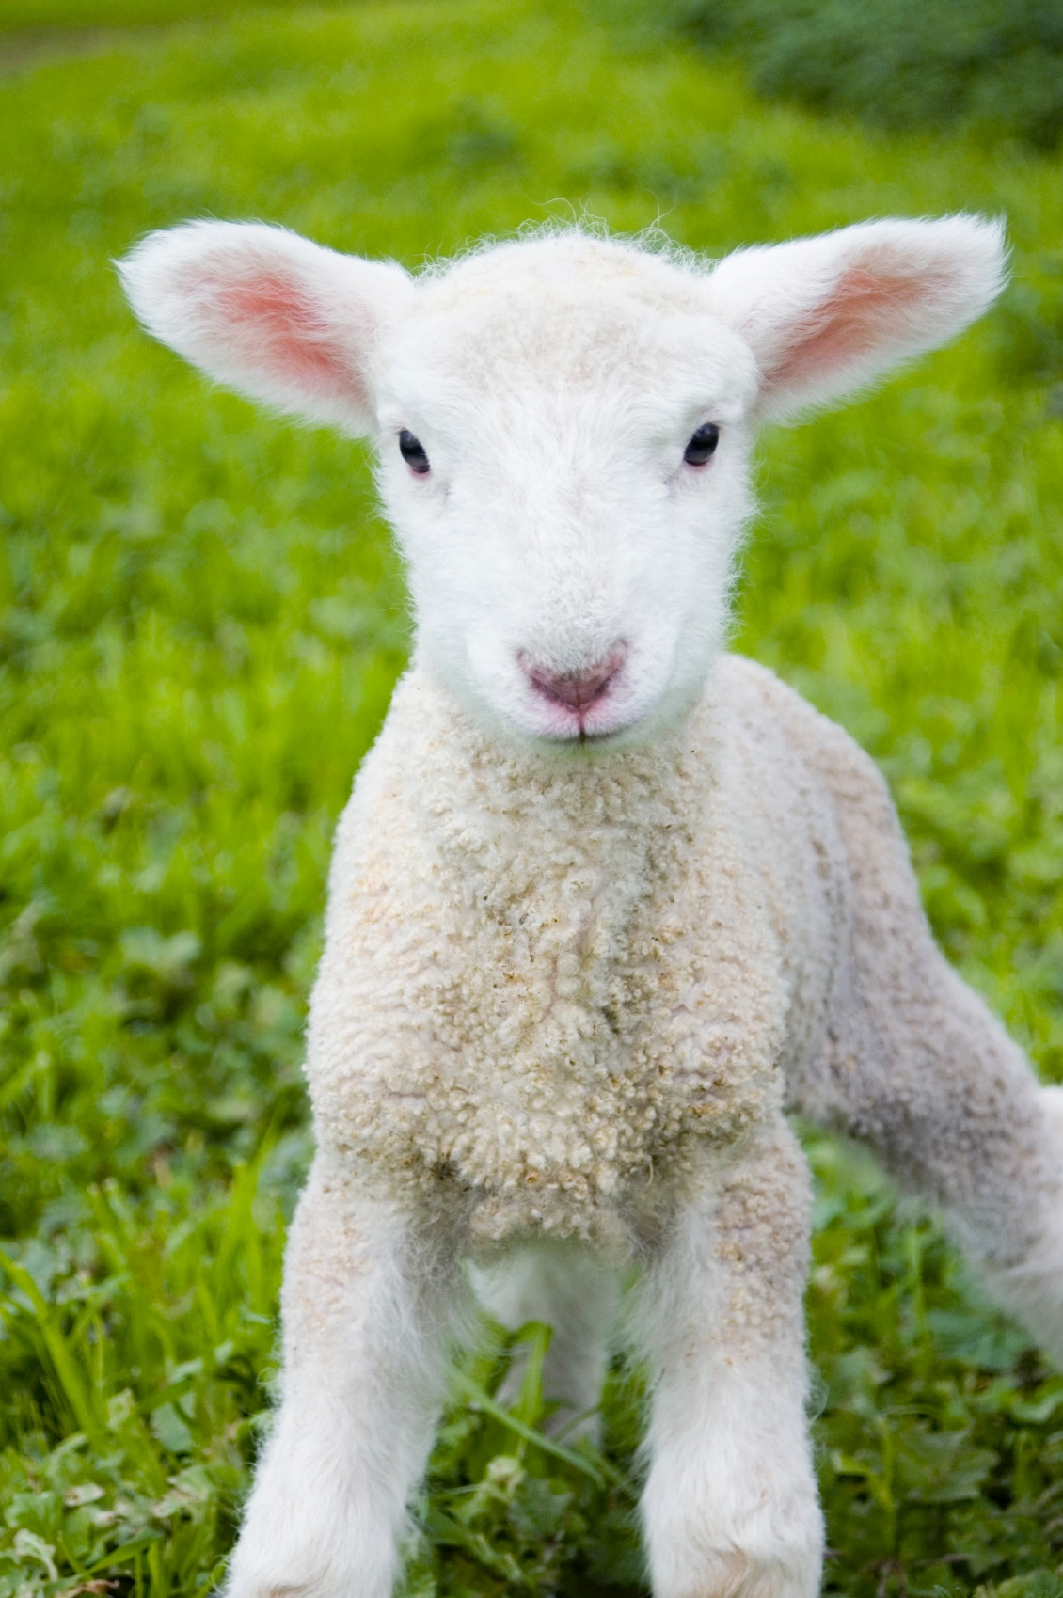
Fees and funding
The fees are £25.80 for the morning session (9:15am to 12:15pm) and £47.30 for the whole day (9:15 am to 2:45pm).
Depending on your child’s date of birth and your family circumstances, you may be entitled to receive 15 or 30 hours funding per week, we offer the following funding.
FEEE2W – Working Parent Funding Entitlement from the term after a child turns 2-years-old.
• FRAS (FEEE2) – Funding Entitlement for eligible families who receive additional Support, from the term after a child turns 2-years-old.
• FEEE3-4 – Universal Funding Entitlement available to all children from the term after a child turns 3-years-old.
• EFE – Extended Funding Entitlement for Working Parents available to eligible Working Parents from the term after a child turns 3-years-old.
We require a full term’s notice in writing if you wish to withdraw your child from the nursery.

day session, we don’t offer afternoon session only. Fees are due in advance for each term in full on issue of invoice. Free Early Education Entitlement for 2 and 3-4 year olds is available for up to 15 hours per week. We also offer extended entitlement (30 hours) for working parents, however the number of funded places are limited. We require a full term’s notice in writing if you wish to withdraw your child from the nursery.
Premises
We have two playrooms with lots of natural light.
We have a modern kitchen and toilet facilities, a secure entry system with a bell and two secure garden areas.
There is a car park available for dropping off, picking up and for the church cafe only. There is full disabled access and a lift within the building.
Downstairs is a coffee bar where parents/carers can relax after dropping off their children or while waiting to pick them up.
We aim to ensure that each child. . .
. . . is in a setting that sees parents/carers as partners in helping each child to learn and develop.
. . . and their parent(s)/carer(s) are offered a service that promotes equality and values diversity.
. . . is in a safe and stimulating, fully inclusive environment
Attendance at Little Lambs
Your child has the opportunity to attend Little Lambs 4 to 10 sessions per week, and days preferred should be entered on the registration form. If you wish to make changes to the days your child attends please let us know in writing and we will endeavour to accommodate all changes, subject to availability. A term’s notice is needed for any changes in sessions.
Our aims at
Little Lambs
• Every child will be encouraged to reach their full potential in a secure, caring and happy environment.
• Every child will be encouraged to develop their individual growth in social skills, independence and general knowledge.
• Every child will be encouraged to access the seven areas of learning through play.
• Every child will be encouraged by their own individual ‘key person’ who will oversee their progress and achievements.
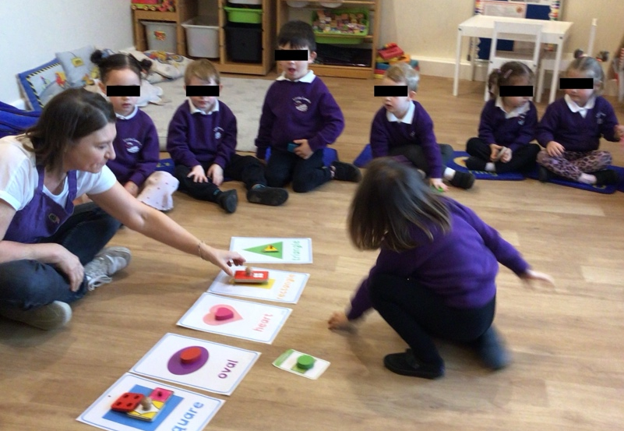
Outdoor
exploration
There are seven interconnected areas of Learning and Development.
Prime Areas:
• Personal, social and emotional development
• Communication and language
• Physical development
Specific Areas:
• Literacy
• Mathematics
• Understanding the world
• Expressive Arts and Design
These areas of learning are delivered through carefully planned topics, where they will learn through purposeful play, in both adult-led and child-initiated activities. We welcome the contribution of parent(s)/guardian(s)/carer(s) both at home and in setting to enhance these topics.
Physical play
Children’s learning and development
Creative play
Self confidence
Mark making
Little Lambs Timetable
and Routines
We believe that care and education are equally important and so the routines and activities that make up the morning are provided in ways that. . .
• help each child to feel that they are a valued member of Little Lambs.
• ensure the safety of each child.
• help children to benefit from the social experience of being part of a group.
• provide children with the opportunities to learn.
• introduce them to new experiences and help them gain new skills.
• help them work with others, in both child-chosen and adult- led activities.
At Little Lambs we aim to give every child the best possible start in life and, with the help of our very committed staff, we will help the children fulfil their potential.
The Early Years Foundation Stage is the framework we follow to ensure that, as providers, we are delivering the quality child care necessary for children to make the most of their abilities and talents as they grow up.
In the morning after registration we have ‘circle time’ where we greet each other, discuss the day/season and talk about the week’s theme/topic. Free play follows where children can access the snack table and everything from painting, drawing and play-dough to time in the garden, the home corner and the library. The children end their morning with music, stories or by taking part in a physical activity.
Learning through play

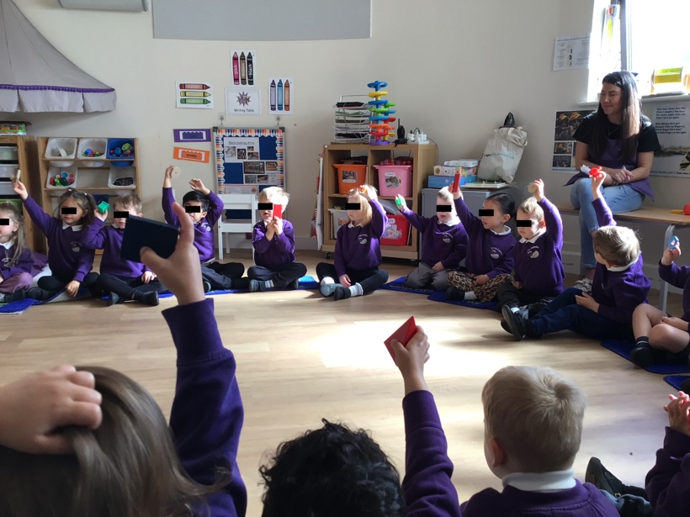
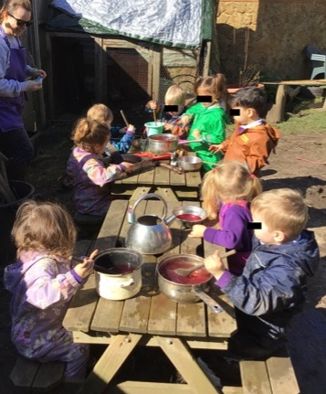
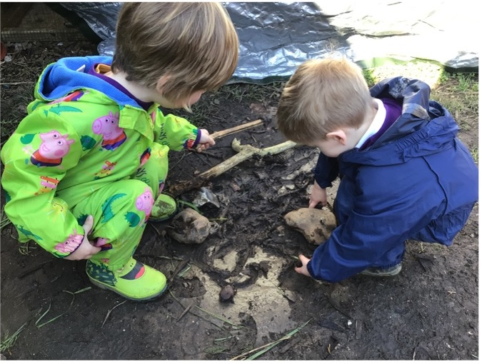
Festivals and celebrations
Little Lambs is a Christian based setting where children will be encouraged to understand the Christian way of life (which includes a prayer at circle time and singing Grace before snack time) and the special significance of Jesus.
We encourage parents/carers to bring special cultural events and festivals into our setting for all the children and staff to share.
We all love celebrating our birthdays and so children are encouraged to bring in one of their gifts for “show and tell” at circle time. At the end of the session parents can join in the birthday
celebration.
Healthy eating
Our snack time each morning is a very sociable occasion where children sit with an adult to communicate, share and experience different tastes and textures. We offer organic milk or water to drink as well as a range of food, which may be theme, season or festival related. (Children with special dietary requirements will be catered for.)
Uniform
The uniform is a white polo shirt, purple sweatshirt, purple dress/skirt, cardigan and plimsolls which can be purchased from the nursery and should be clearly named. One complete uniform is included as part of your child’s starter pack. Second-hand uniform is also available.

Every child at Little Lambs has the opportunity to venture into our forest garden, where it is okay for your children to throw themselves fully and completely into the serious business of play.
Our children can sweep in puddles with child-sized brooms: and search for bugs and grubs! We participate in nature based crafts, build hedgehog houses and dens, watch tadpoles change into frogs, eat and drink outside and watch as our garden changes with the different seasons.

We have a small forest garden that gives them the freedom and time to do things- like play in puddles – explore, be creative, be inquisitive, messy, learning about nature, activities that parents might not be able to embrace at home.
Why play outdoors?









Little Lambs
St Mary’s Church 201 High Road Loughton
Essex IG10 1BB
Tel: 07769 433023
E-mail: littlelambs@stmarysloughton.com

REGISTRATION/WAITING LIST FORM
I would like to enrol my child at Little Lambs. I am enclosing a deposit of £45 by bank transfer to HSBC, Sort Code: 40-30-25, Account No: 51450069. No deposit is required for children eligible for FEEE2 and for children fully funded FEE2/3W (15/30 hours). I understand this is the cost of the registration and starter pack*. On receipt of your completed registration form and deposit you will receive confirmation of your application by email and your child’s name will go on the waiting list. (Deposits are only refunded if no place becomes available for your child)
*starter pack includes: polo shirt, sweatshirt and plimsolls.

PERSONAL DETAILS
Child’s Full Name Sex (Boy/Girl)

Date of Birth Home Tel No. Home Email

Address

Mother’s name Mobile/Work Tel No

Father’s name Mobile/Work Tel No

ATTENDANCE REQUIREMENTS
Sessions available are mornings 9:15 am to 12:15 pm or all day 9:15 am to 2:45 pm (all day counts as 2 sessions).

How many sessions do you require in total per week (minimum 4 up to 10 sessions)? ____
Please CIRCLE below your first and second choice (4 sessions minimum)

FIRST CHOICE SECOND CHOICE
Monday morning/all day Monday morning/all day
Tuesday morning/all day Tuesday morning/all day
Wednesday morning/all day Wednesday morning/all day
Thursday morning/all day Thursday morning/all day
Friday morning/all day Friday morning/all day

Start Date Required (please CIRCLE): Sept 2027/ Sept 2028 / Sept 2029 Anticipated leaving date

Does your child attend any other setting, if so, which one?

Do you currently attend a place of worship and, if so, which one?

SIGNATURE
Where a child has more than one Parent/Guardian/Carer both must sign.
I/We have read and agree to the fees, terms and conditions enclosed and certify that all information given in this form is correct. I/We will inform Little Lambs Ltd in writing should any of the details on the Registration Form change.

Signed Date Signed Date

09 Early years practice procedures
09.1 Waiting List and Admissions
Statement of Intent
We are committed to providing an inclusive, welcoming and accessible environment that promotes equality of opportunity for all children and families. We aim to ensure that our admissions procedures are fair, transparent and non-discriminatory, and that children are able to access high-quality early education and childcare, regardless of their background, culture, religion, ethnicity, gender, family circumstances, disability or special educational needs. This policy is implemented in accordance with the Early Years Foundation Stage (EYFS), the Equality Act 2010, the Children and Families Act 2014 and the SEND Code of Practice. [gov.uk], [council for...ren.org.uk], [asset.nasen.org.uk]
Waiting List
- The setting is widely advertised in ways that are accessible to all sections of the community.
- We provide information about our provision in clear, plain English and, where possible, offer it in alternative languages or formats upon request.
- The waiting list is maintained in date order of application.
- In allocating places, the setting may also take the following factors into account:
  - the age of the child;
  - the proximity of the child's home to the setting;
  - siblings already attending the setting;
  - exceptional family circumstances, including illness, bereavement, or lone-parent households;
  - the setting's ability to safely meet the child's individual needs after all reasonable adjustments, available funding, specialist advice and support options have been fully explored and considered.
- Where financially viable, a place may be reserved for emergency admissions.
- Funded places are offered in accordance with current government guidance and local authority requirements. [gov.uk]

Equality, Diversity and Inclusion
- The setting welcomes children and families from all backgrounds.
- Fathers, mothers, carers, guardians, extended family members, and childminders are all welcomed and respected.
- We actively promote positive attitudes towards diversity and inclusion and value differences in:
  - gender;
  - family structure;
  - social and economic background;
  - religion or belief;
  - ethnicity;
  - culture;
  - language;
  - disability and additional needs.
- The setting will not treat a child less favourably because of a disability, special educational need, medical condition or other protected characteristic.
- We will consider and implement reasonable adjustments wherever possible to enable children with disabilities and SEND to access our provision and participate fully in all activities. [council for...ren.org.uk], [asset.nasen.org.uk]
- The setting shares its Equality and Inclusion Policy with parents and carers and makes it available on request.

Admissions
Once a place has been offered, the manager or deputy manager will ensure that all required documentation is completed before the child starts attending.
The following documents must be completed and retained within the child's file:
Privacy Notice (07.1a)
This explains:
- what personal information is collected;
- why it is collected;
- how it is used;
- how it is stored and protected; and
- the rights of parents and carers regarding their personal data.
Early Education and Childcare Terms and Conditions (09.1d)
This outlines the terms under which childcare and early education are provided.
Early Education and Childcare Registration Form (09.1c)
This records essential information relating to:
- the child;
- parents and carers;
- emergency contacts;
- medical needs;
- dietary requirements;
- additional needs and support arrangements.
Failure to comply with the setting's terms and conditions may result in a place being withdrawn.

Children with Special Educational Needs and Disabilities (SEND)
The setting is committed to inclusive practice and will not refuse admission solely because a child has Special Educational Needs and/or Disabilities (SEND). [council for...ren.org.uk], [gov.uk]
Assessment and Planning
- At registration, the setting will work in partnership with families, the local authority and relevant professionals to identify and implement reasonable adjustments that support inclusion and accessibility.
- Reasonable adjustments may include:
  - staff training
  - environmental adaptations
  - individual risk assessments
  - healthcare plans
  - adapted resources and equipment
  - additional staffing arrangements
  - specialist professional advice and support
- Where additional support is identified, the setting will consider appropriate interventions and support strategies at the earliest opportunity.
- If a child's needs cannot reasonably be met through the setting's core budget, applications for SEN Inclusion Funding, Disability Access Funding or other available funding streams will be made promptly.
Children with Complex Needs
- Where a child has complex SEND or medical needs, a start date may be dependent upon the completion of reasonable preparations required to ensure:
  - the child's safety;
  - the child's wellbeing;
  - effective inclusion;
  - the safety and well-being of others.
- The setting will provide parents/carers with clear information regarding any preparatory actions and proposed timescales.
- During any preparation period, communication with parents/carers, professionals and the local authority will be maintained regularly.
Where Concerns Exist About Meeting Need
- If concerns arise about the setting's ability to meet a child's needs safely and effectively, the manager and SENCO will work with parents/carers, professionals and the local authority to explore:
  - all reasonable adjustments;
  - available funding;
  - specialist support;
  - workforce development;
  - environmental adaptations;
  - alternative approaches that may support successful inclusion.
- Any decision that a child's needs cannot be met within the setting will only be reached after all reasonable adjustments and available support options have been thoroughly explored and documented.
- Such decisions will be evidence-based, proportionate, clearly recorded and made in the best interests of the child, while taking account of the setting's legal obligations under the Equality Act 2010, Children and Families Act 2014, SEND Code of Practice and EYFS Framework. [council for...ren.org.uk], [gov.uk], [asset.nasen.org.uk]
- Any delay in admission will be kept to the minimum necessary and regularly reviewed to avoid discrimination and unnecessary disadvantage to the child or family.
Disability Access Fund (DAF)
- During registration, the manager will establish whether the child is in receipt of Disability Living Allowance (DLA).
- Where eligible, the setting will support families to access Disability Access Funding and any other appropriate support.
Safeguarding and Child Protection
- If parents/carers inform the setting that a child is currently, or has previously been, involved with Children's Social Care, the Designated Safeguarding Lead (DSL) will seek appropriate information from the relevant agency to ensure the child's safety and welfare needs are understood.
- Any information received will be treated confidentially and managed in accordance with safeguarding, child protection and data protection requirements.
- Parents/carers will be informed how to access the setting's policies and procedures.

Monitoring and Review
The manager and SENCO will monitor admissions and waiting list arrangements regularly to ensure:
- fairness and transparency;
- compliance with equality legislation;
- effective inclusion of children with SEND;
- appropriate implementation of reasonable adjustments; and
- equitable access to early education and childcare for all families.
This policy will be reviewed annually, or sooner if there are changes to legislation, statutory guidance or local authority requirements.

